Discussion

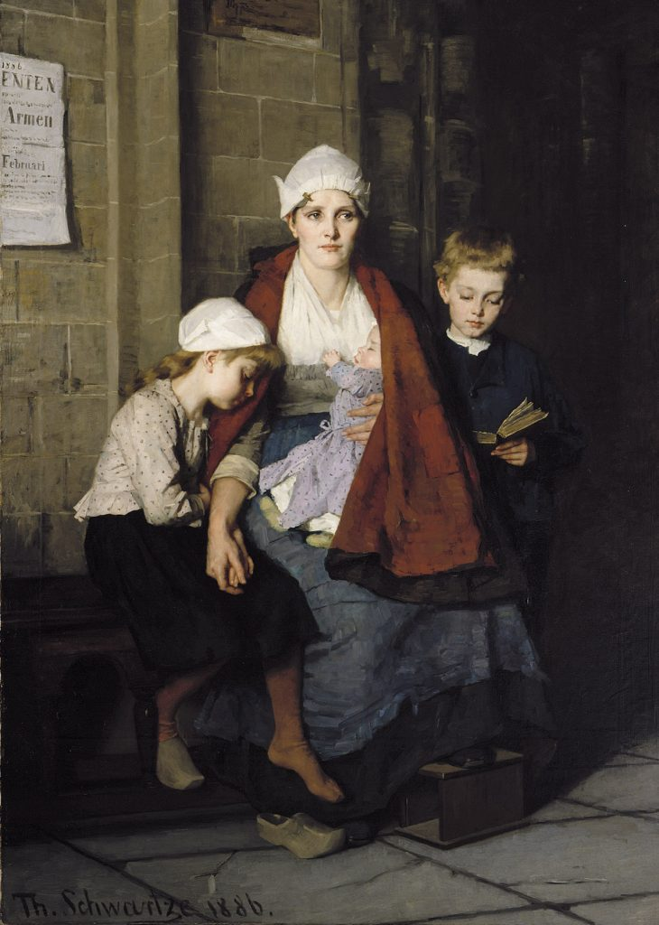

Thérèse Schwartze

Amsterdam 1851 – Amsterdam 1918

DESCRIBE THIS PICTURE?

WHAT IS SPECIAL ABOUT THIS FAMILY PORTRAIT?

IS SOMEONE MISSING FROM THIS FAMILY PORTRAIT?

DO THEY SEEM HAPPY?

WHAT DO YOU THINK IS HAPPENING ?



Jean Paul Lemieux

Québec 1904 – Québec 1990

DESCRIBE THIS PICTURE?

WHY WOULD WE SAY THAT THIS FAMILY PORTRAIT IS “ATYPICAL”?

IS YOUR FAMILY ATYPICAL?

IF YOU WERE TO TAKE A FAMILY PORTRAIT, WHO WOULD BE A PART OF IT?

SHARE A FAMILY PICTURE…DESCRIBE THE MEMBERS OF YOUR FAMILY

DO YHEY SEEM HAPPY?

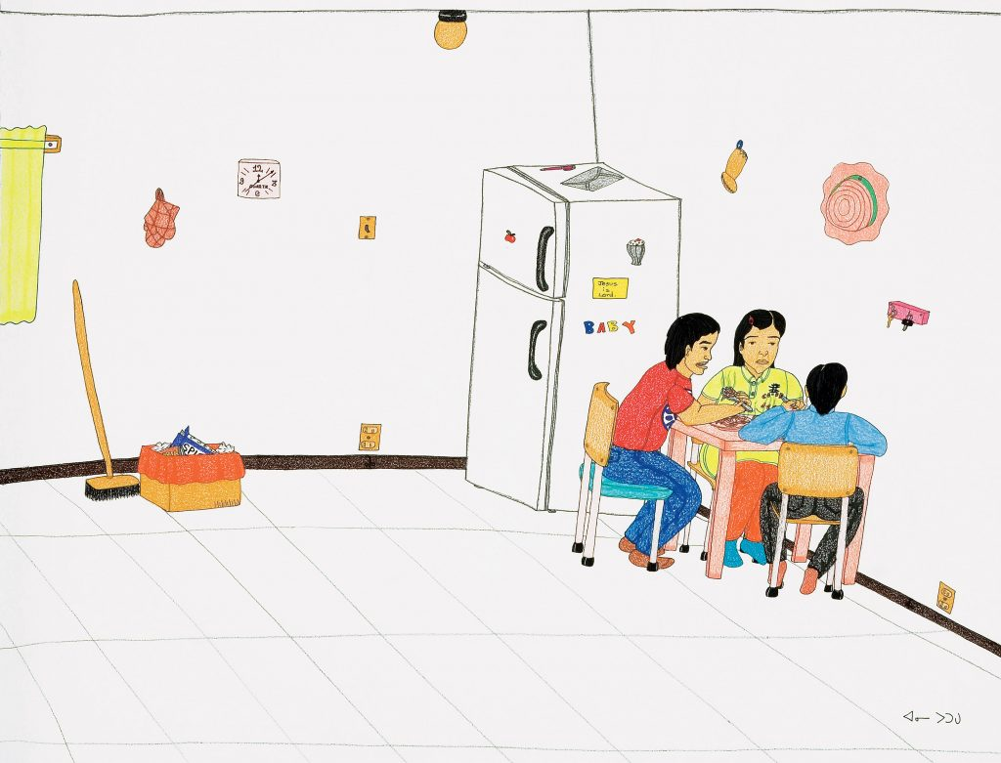

Cape Dorset (Nunavut) 1969 – Ottawa 2016

WHAT DO YOU SEE?

WHO IS EATING AT THE DINNER TABLE?

WHO DO YOU NORMALLY EAT DINNER WITH?

DO THEY SEEM HAPPY?

DOES YOUR KITCHEN LOOK SIMILAR, LIST THE SIMILARITIES…

TYPES OF FAMILIES

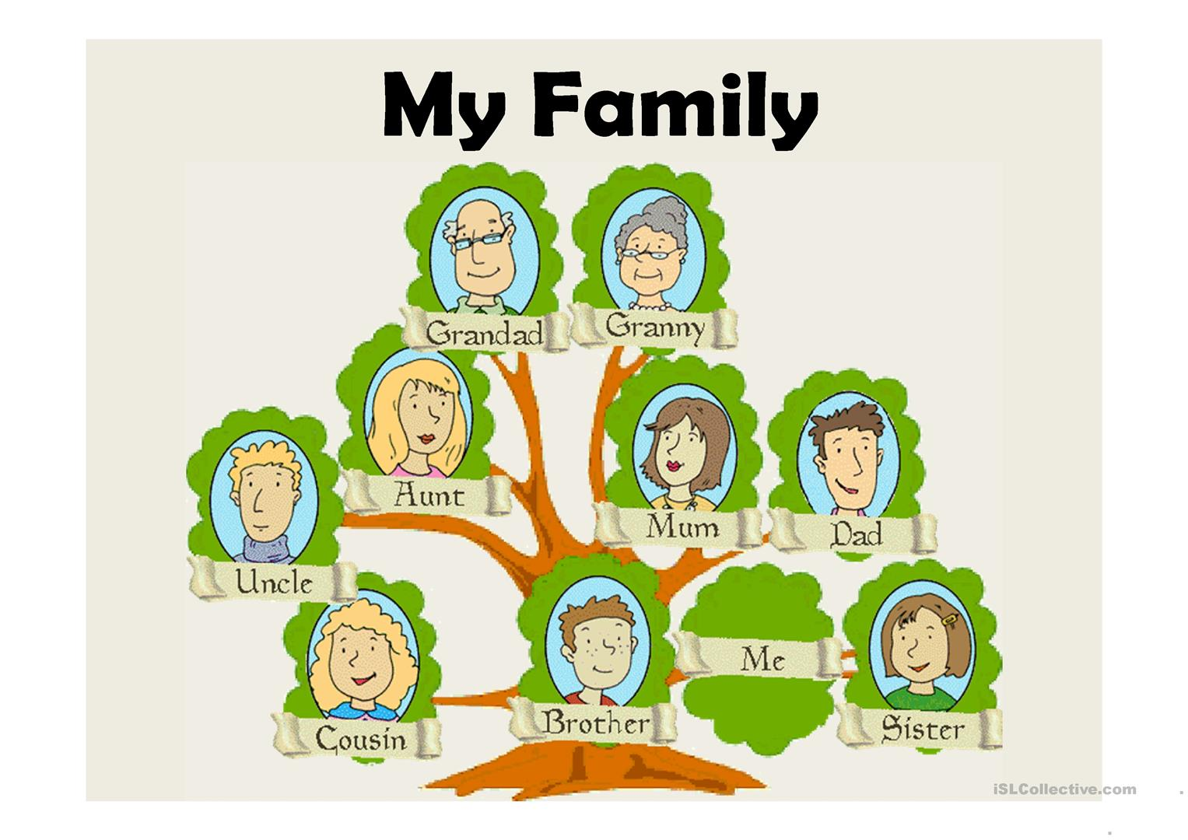

**Nuclear Family**

The [nuclear family](https://family.lovetoknow.com/definition-nuclear-family) is the traditional type of family structure. This family type consists of two parents and children. The nuclear family was long held in esteem by society as being the ideal in which to raise children.

### Single Parent Family

The [single parent family](https://family.lovetoknow.com/single-parent-family) consists of one parent raising one or more children on his own. This family may include a [single mother](https://pregnancy.lovetoknow.com/wiki/Single_Mom) with her children, a single dad with his kids, or a single person with their kids.

### Extended Family

The [extended family](https://family.lovetoknow.com/about-family-values/definition-extended-families) structure consists of two or more adults who are related, either by blood or marriage, living in the same home.

### Step Family

Over half of all [marriages end in divorce](https://divorce.lovetoknow.com/Historical_Divorce_Rate_Statistics), and many of these individuals choose to get remarried. This creates the step or [blended family](https://family.lovetoknow.com/definition-blended-family) which involves two separate families merging into one new unit.

### Grandparent Family

Many grandparents today are [raising their grandchildren](https://seniors.lovetoknow.com/Women_Who_Raise_Their_Grandchildren) for a variety of reasons. [One in fourteen children](http://www.prb.org/Publications/Articles/2012/US-children-grandparents.aspx) is raised by his grandparents, and the parents are not present in the child's life.

Journal Entry

What type of family do you have?

How many siblings do you have?

Do you have a step father/mother?

Do you have step sisters/brothers?

Who do you get along the most with?

Who do you get along the least with?

Who do you ressemble the most? (Physically)

What personality traits do you have in common with… Mom? Dad? Sister?brother? grandpa? Grandma? Cousin?

Are you the eldest? The youngest? The middle child? An only child?

What is one memory you cherish from your childhood?

Grammar

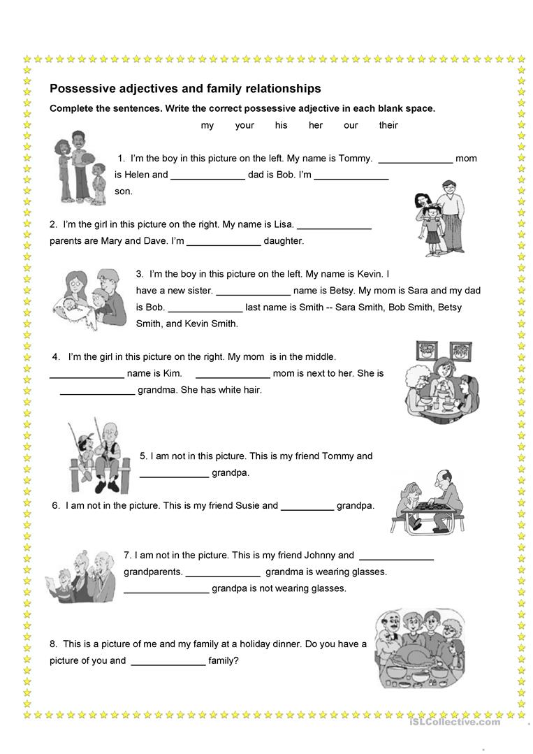

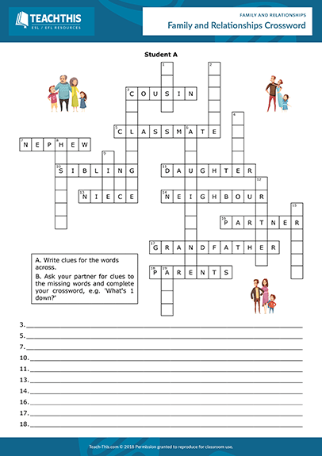

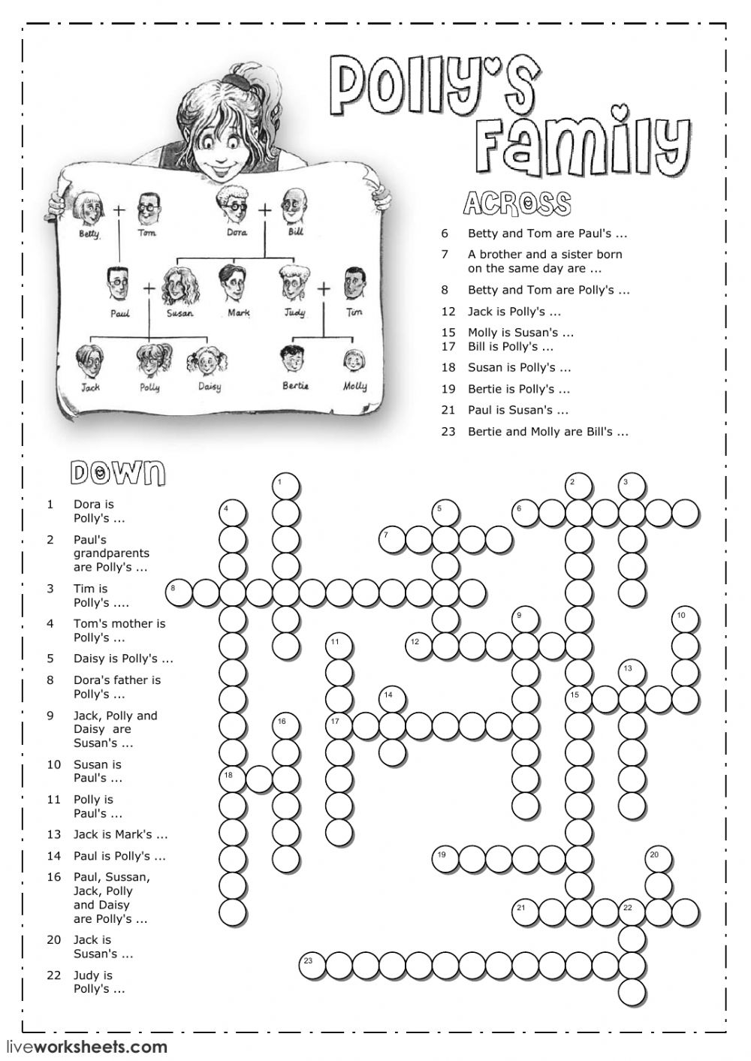

C2 Listening Activity

<https://www.youtube.com/watch?v=lDZA54Bi8sg>

Listen to Paul describing his family.

Answer the following questions

C2 Reading Comprhension

https://dl.pearson.co.jp/resources/9780133810516/teachers.pdf

Family Portrait

Bring a picture of your family/ draw an image of your family and insert a short caption telling us about your family ties…

Tell us your family members’ names…

Their age…

Their profession…

What activities do you do as a family?

What makes your family special?

Bring an object that best describes your family…

